LAB MANUAL# 9
OBJECTIVES:
- To learn and understand how to design a multiple output combinational circuit
- To learn and understand the working of 2-bit binary comparator
- Adder/Subtractor

APPARATUS: Logic trainer, Logic probe
COMPONENTS: ICs 74LS08, 74LS32, 74LS04, 74LS86, 74LS02
THEORY:
Binary comparator is a combinational circuit that compares magnitude of two binary data signals A & B and generates the results of comparison in the form of three output signals A>B, A=B, A<B.
One-bit comparator:
One-bit comparator compares magnitude of two numbers A and B, 4 bit each, and generates the comparison result. The result consists of three outputs let us say L, E, G, so that
$$L=1 if A<B$$
$$E=1 if A=B$$
$$G=1 if A>B$$
Truth Table:
Inputs |  | Outputs
A | B | L | E | G
0 | 0 | 0 | 1 | 0
0 | 1 | 1 | 0 | 0
1 | 0 | 0 | 0 | 1
1 | 1 | 0 | 1 | 0

K-Maps for Outputs:
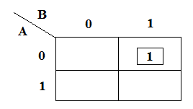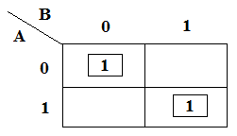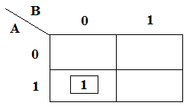
K-Map for Output L K-Map for Output E K-Map for Output G
Boolean Expressions of Outputs:
L: $\overline{A}B______$
E: $AB+ \overline{A}\overline{B}_$
G: $A\overline{B}______$
Exclusive-OR & Exclusive-NOR gates:
The figure given below shows the symbol of Exclusive-OR (XOR) and Exclusive-NOR (XNOR) gates.
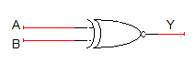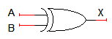
XNOR gate XOR gate
Boolean expression of XNOR gate is$AB+ \overline{A}\overline{B}$ and Boolean expression of XOR is$\overline{A}B+A\overline{B}$. Boolean expression of XNOR gate can be implemented using XOR gate as shown in figure below:
Circuit Diagram for one-bit comparator:

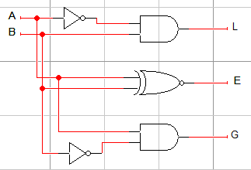

In this experiment 74LS86 IC will be used for implementation of XOR gate function. 74LS86 IC contains four 2-input XOR gates. The function table and connection diagram for this IC are shown below:
Function Table:
Inputs |  | Output
A | B | Y
L | L | L
L | H | H
H | L | H
H | H | L
H= Logic High, L= Logic Low

Connection Diagram:
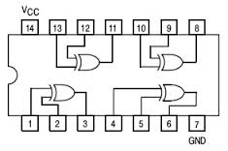
LAB TASK 1:
Design a combinational circuit that compares two 2-bit numbers and generates the comparison result. The result consists of three outputs let us say L, E, G, so that
$$L=1 if A<B$$
$$E=1 if A=B$$
$$G=1 if A>B$$
- Write truth table

- Find minimal SOP expressions for the outputs L, E, and G using K-map. Draw separate K-map for each output in the space given below.

- Fill the following table in order to determine the gate cost for the implementation of binary comparator using SOP expressions found in part (b)

IC type | Required No. of Gates | Gates per IC | Required No. of ICs
Total no. of ICs

Adder and subtractor
Half Adder:
Half adder is a logic circuit that performs binary addition of two 1-bit numbers. It generates two outputs namely ‘Sum’ and ‘Carry’.
Truth Table:
A | B | Carry | Sum
0 | 0 | 0 | 0
0 | 1 | 0 | 1
1 | 0 | 0 | 1
1 | 1 | 1 | 0

Boolean Expressions of Outputs:

$Sum=A⊕B$
$Carry=AB$
Half Subtractor:
Half subtractor is a logic circuit that performs binary subtraction of two 1-bit numbers. It generates two outputs namely ‘Difference’ and ‘Borrow’.
Truth Table:
A | B | Borrow | Difference
0 | 0 | 0 | 0
0 | 1 | 1 | 1
1 | 0 | 0 | 1
1 | 1 | 0 | 0

Boolean Expressions of Outputs:

$Difference=A⊕B$
$Borrow= \overline{A}B$

Full Adder:
Full adder is a logic circuit that performs binary addition of two 2-bit numbers. It generates two outputs namely ‘Sum’ and ‘Carry’.

Truth Table:
A | B | C | Carry | Sum
0 | 0 | 0 | 0 | 0
0 | 0 | 1 | 0 | 1
0 | 1 | 0 | 0 | 1
0 | 1 | 1 | 1 | 0
1 | 0 | 0 | 0 | 1
1 | 0 | 1 | 1 | 0
1 | 1 | 0 | 1 | 0
1 | 1 | 1 | 1 | 1

Boolean Expressions of Outputs:

$Sum=A⊕B⊕C$
$Carry= AB+BC+AC$or $Carry= AB+C(A⊕B)$

Full Subtractor:
Full subtractor is a logic circuit that performs binary subtraction of two 2-bit numbers. It generates two outputs namely ‘Difference’ and ‘Borrow’.
Truth Table:

A | B | C | Borrow | Difference
0 | 0 | 0 | 0 | 0
0 | 0 | 1 | 1 | 1
0 | 1 | 0 | 1 | 1
0 | 1 | 1 | 1 | 0
1 | 0 | 0 | 0 | 1
1 | 0 | 1 | 0 | 0
1 | 1 | 0 | 0 | 0
1 | 1 | 1 | 1 | 1

Boolean Expressions of Outputs:

$Difference=A⊕B⊕C$
$Borrow= \overline{A}B+BC+\overline{A}C$or $Carry= \overline{A}B+C(\overline{A}⊕B)$

LAB TASK 2:
Implement 4-bit full adder and full subtractor on logic works.

LAB TASK 3:
Implement a 4-bit multiplier using the 4-bit full adder of LAB TASK 2.

